NAME: YASIR FAHEEM

ROLL NUMBER: SMIT-205861

CLASS: FLUTTER PROGRAMMING

TEACHER: BILAL REHMAN

ASSIGNMENT NO 1

// Q.1: Create two integer variables length and breadth and assign values then

// check if they are square values or rectangle values.

// ie: if both values are equal then it's square otherwise rectangle.

void main(){

print("YASIR FAHEEM");

print("Assingment no 1");

print("Q.1: Create two integer variables length and breadth and assign values then \n check if they are square values or rectangle values.\n ie: if both values are equal then it's square otherwise rectangle.");

num length = 21;

num breath= 21;

if(breath==length){

    print("Answer is :   its square");

}

else{

    print("Answer is :    its rectangle");

}

}

OUTPUT

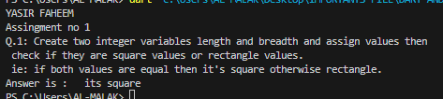

// question no 2 Take two variables and store age then using if/else condition to determine

// oldest and youngest among them.

void main(){

print("YASIR FAHEEM");

print("Assingment no 1");

print("Q2 :Take two variables and store age then using if/else condition to determine \n oldest and youngest among them.");

 int age1 = 18;

 //age1 is for young man

 int age2 = 40;

//age2 is for old man

if (age1<=age2){

  print(" age1 you are young man");

}

else{

  print ("you are old man");

}

}

OUTPUT

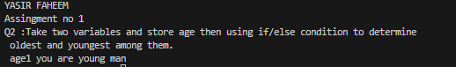

// Q.3: A student will not be allowed to sit in exam if his/her attendance is less

// than 75%. Create integer variables and assign value:

// Number of classes held = 16,

// Number of classes attended = 10,

// and print percentage of class attended.

// Is student is allowed to sit in exam or not?

void main(){

print("YASIR FAHEEM");

print("Assingment no 1");

print("Q.3: A student will not be allowed to sit in exam if his/her attendance is less \n than 75%. Create integer variables and assign value: \n Number of classes held = 16, /n Number of classes attended = 10, /n and print percentage of class attended. \nIs student is allowed to sit in exam or not?");

int classes_held = 16;

int attend_class =10;

num percentage;

percentage= (10/16)*100;

print("$percentage%");

if(percentage>=75)

{

  print("you are allowed in exam");

}

else{

  print("you are not allowed in exam");

}

}

OUTPUT

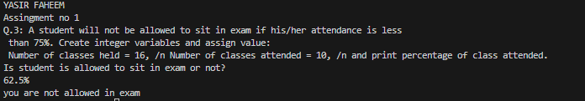

// Q4: Write a program to convert Celsius to Fahrenheit .

// i.e: Temperature in degrees Fahrenheit (°F) = (Temperature in degrees Celsius

// (°C) * 9/5) + 32

void main(){

print("YASIR FAHEEM");

print("Assingment no 1");

print("Q4: Write a program to convert Celsius to Fahrenheit .\n i.e: Temperature in degrees Fahrenheit (°F) = (Temperature in degrees Celsius \n (°C) * 9/5) + 32");

print("Answer\n");

num temp_celsius = 30;

num temp_fahrenheit= (temp_celsius*(9/5)+32);

print(temp_fahrenheit);

}

OUTPUT

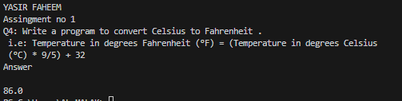

// Q.5 Write a program to read temperature in centigrade and display a suitable

// message according to temperature:

// You have num variable temperature = 42;

// Now print the message according to temperature:

// temp < 0 then Freezing weather

// temp 0-10 then Very Cold weather

// temp 10-20 then Cold weather

// temp 20-30 then Normal in Temp

// temp 30-40 then Its Hot

// temp >=40 then Its Very Hot

void main(){

print("YASIR FAHEEM");

print("Assingment no 1");

print("Q.5 Write a program to read temperature in centigrade and display a suitable\nmessage according to temperature:\nYou have num variable temperature = 42;\nNow print the message according to temperature:\ntemp < 0 then Freezing weather\ntemp 0-10 then Very Cold weather\ntemp 10-20 then Cold weather\ntemp 20-30 then Normal in Temp\ntemp 30-40 then Its Hot\n temp >=40 then Its Very Hot");

print("Answer\n");

int temp = 42;

if(temp<0)

{

  print("Freezing weather");

}

else if (temp>=0 && temp < 10)

{

  print("very cold weather");

}

else if (temp>=10 && temp < 20)

{

  print("its cold weather");

}else if (temp>=20 && temp < 30)

{

  print("this is normal temperature");

}else if (temp>=30 && temp < 40)

{

  print("its hot weather");

}else if (temp>=40)

{

  print("its very hot weather");

}

}

OUTPUT

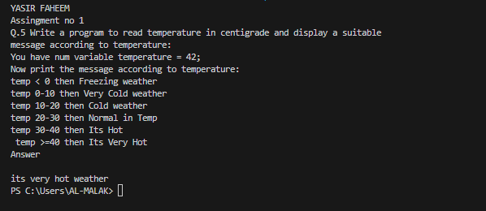

// Q.6: Write a program to check whether an alphabet is a vowel or consonant.

void main(){

print("YASIR FAHEEM");

print("Assingment no 1");

print("Q.6: Write a program to check whether an alphabet is a vowel or consonant.");

print("Answer\n");

String alphabet="b";

if(alphabet=="a" || alphabet=="e"|| alphabet=="i" || alphabet=="o" || alphabet=="u" ){

print("the $alphabet is vowels");

}

else{

  print("the $alphabet is consonants");

}

}

OUTPUT

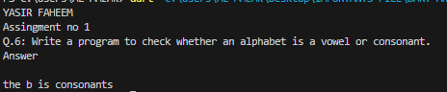

import 'dart:math';

// Q.7: Write a program to calculate root of any number.

// i.e: √y = y1⁄2

void main(){

print("YASIR FAHEEM");

print("Assingment no 1");

print("Write a program to calculate root of any number.\n i.e: √y = y1⁄2");

print("Answer\n");

double y =36;

print("the value of y is $y");

double power=1/2;

print("√y = y1⁄2");

print(pow(y , power));

}

OUTPUT

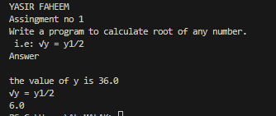

import 'dart:math';

// Q8: Create a marksheet using operators of at least 5 subjects and output

// should have Student Name, Student Roll Number, Class, Percentage, Grade

// Obtained etc.

// i.e: Percentage should be rounded upto 2 decimal places only.

void main(){

print("YASIR FAHEEM");

print("Assingment no 1");

print("Q8: Create a marksheet using operators of at least 5 subjects and output\nshould have Student Name, Student Roll Number, Class, Percentage, Grade\nObtained etc.\ni.e: Percentage should be rounded upto 2 decimal places only.");

print("Answer\n");

String studentName= "Yasir faheem";

print("Student Name is $studentName");

String studentRollnumber= "Smit-06";

print("Student Roll Number is $studentRollnumber");

String studentClass= "Matric class";

print("Student Class is $studentClass");

print("Subject of Matric class is : \n 1) Mathematics \n 2) Urdu \n 3)Islamiat \n 4)Physics \n 5)English ");

num mathematics_marks =70;

print("marks of mathematics is : $mathematics_marks");

num urdu_marks =60;

print("marks of Urdu is : $urdu_marks");

num islamiat_marks =80;

print("marks of Islamiat is : $islamiat_marks");

num physics_marks =70;

print("marks of Physics is : $physics_marks");

num english_marks =70;

print("marks of English is : $english_marks");

num obtained_marks = (mathematics_marks+urdu_marks+islamiat_marks+physics_marks+english_marks);

print("Obtain marks is $obtained_marks");

num total_marks = 500;

num y= ((obtained_marks/total_marks)*100);

num percentage=y.roundToDouble();

print("$percentage%");

if(percentage>=80 && percentage<100)

{

  print("Your Grade is A+ Congarts!");

}

else if (percentage>=70 && percentage<80)

{

  print("your grade is A Excellect!");

}

else if (percentage>=60 && percentage<0)

{

  print("your grade is B Superb!");

}

else if (percentage>=50 && percentage<60)

{

  print("your grade is C Not bad");

}

else if (percentage<50)

{

  print("your grade is F Better luck next time");

}

}

OUTPUT

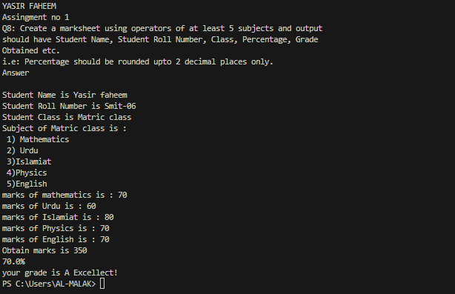

// Q9 Check if the number is even or odd, If number is even then check if this is

// divisible by 5 or not & if number is odd then check if this is divisible by 7 or not.

void main(){

print("YASIR FAHEEM");

print("Assingment no 1");

print("Q9 Check if the number is even or odd, If number is even then check if this is \n divisible by 5 or not & if number is odd then check if this is divisible by 7 or not.");

print("Answer\n");

num number = 21;

if(number % 2==0)

{

  print("number is Even");

  if(number%5==0){

   print("divisible by 5");

  }

  else{

    print("Not divisible by 5");

  }

}

else {

  print("Number is Odd");

    if(number%7==0){

      print("divisible by 7");

    }

    else{

      print("Not divisible by 7");

      }

}

}

OUTPUT

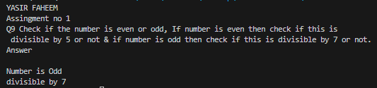

// Q10: Write a program that takes three numbers from the user and prints the

// greatest number & lowest number.

import 'dart:io';

void main(){

print("YASIR FAHEEM");

print("Assingment no 1");

print("Q10: Write a program that takes three numbers from the user and prints the\ngreatest number & lowest number.");

print("Answer\n");

print("Enter the three numbers");

stdout.write("Enter the First number  \n");

num num1 = num.parse(stdin.readLineSync()!);

stdout.write("Enter the Second number  \n");

num num2 = num.parse(stdin.readLineSync()!);

stdout.write("Enter the Third number  \n");

num num3 = num.parse(stdin.readLineSync()!);

//for greatest number

if(num1>num2 && num1>num3)

{

  print("the greatest number is First number which is equal to $num1");

}

else if(num2>num1 && num2>num3)

{

  print("the greatest number is Second Number which is equal to $num2");

}

else if(num3>num2 && num3>num1)

{

  print("the greatest number is Third Number which is equal to $num3");

}

// for lowest number

if(num1<num2 && num1<num3)

{

  print("the Lowest number is First number which is equal to $num1");

}

else if(num2<num1 && num2<num3)

{

  print("the Lowest number is Second Number which is equal to $num2");

}

else if(num3<num2 && num3>num1)

{

  print("the Lowest number is Third Number which is equal to $num3");

}

}

OUTPUT

